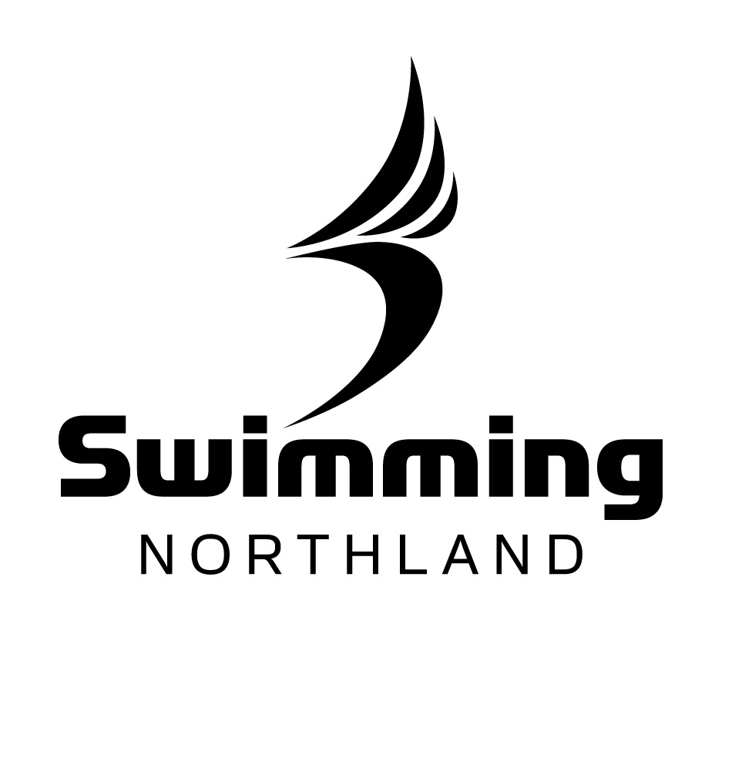
Awards Nomination Form

Swimming Northland clubs are invited to nominate members by the 9th of June 2017 for the following awards:

Service Award: at least 7 continuous (or 9 in total) years of service to a club and or Swimming Northland
Honours Award: At least 5 years of service to a club or Swimming Northland after receiving a Service Award
Life Membership Award: Outstanding continuous service over a long period of time. Must already hold a Service and Honours award.
Mick Parr Trophy: For the swimmer who not only competes but also contributes to club activities.
Administrator of the Year: Awarded to "office bearers" of clubs or organisations, i.e. secretary, treasurer, club captain, committee but does not include coaches. Will have demonstrated a commitment and dedication to the sport of their choice for a period of 12 months or more. Has shown some initiative or been innovative
Coach of the Year: Has made outstanding contribution to a club working on development opportunities and programmes. Has coached a successful club team. Has coached in a club that has seen development of swimmer skills. Has worked on attaining coaching accreditation.
Official of the Year: Has officiated willingly on a regular basis at Regional and/or National meets. Has mentored other officials at regional level. Has worked on attaining recognition at Regional and/or National level. Has achieved the highest possible qualification and/or is an outstanding official.

Nominee………………………………..............................

Nominating Club……………………………….................

Award………………………………..................................

Please provide detailed information attached to this application.
Send all relevant documentation to the Northland Administrator – admin@swimmingnorthland.org.nz or PO Box 564, Paihia, 0247
The Swimming Northland Awards Committee may request further information.
The Awards committee reserves the right to nominate candidates

